**Jorge Rodriguez**

**4/20/2025**

**CS255**

## UML Diagrams

### UML Use Case Diagram

### 

### UML Activity Diagrams

Register & Login Activity Diagram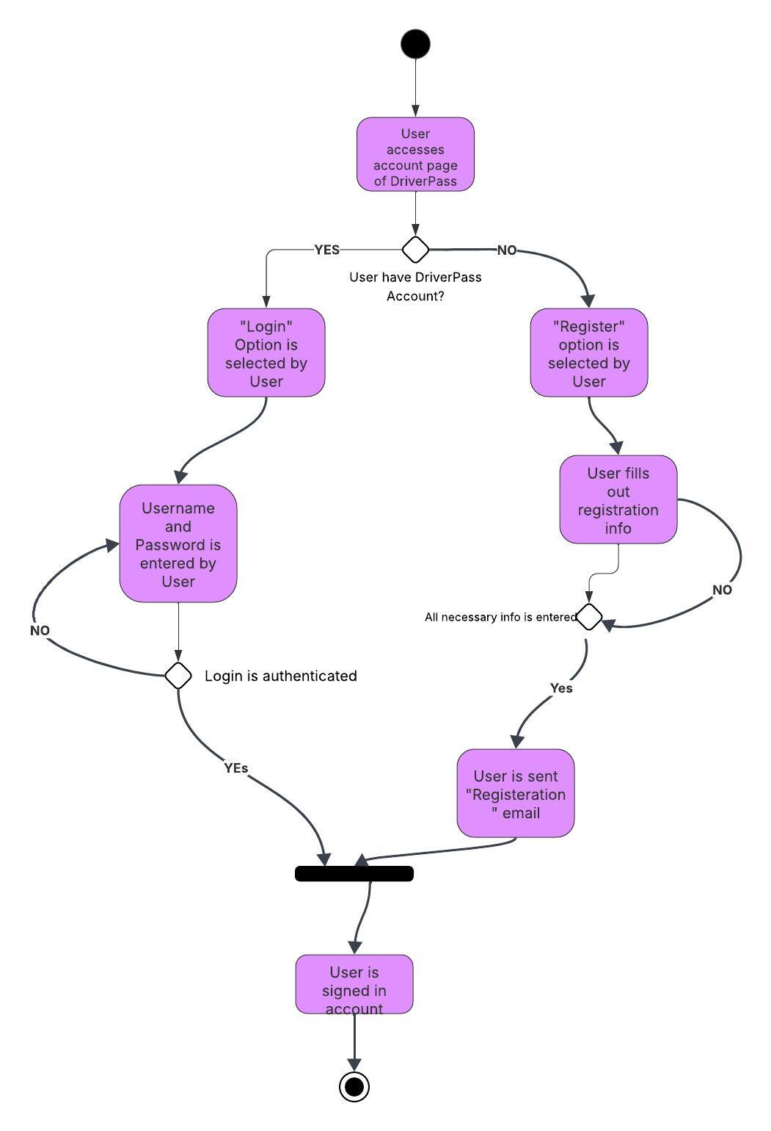

### UML Sequence Diagram

Forgot Password Sequence Diagram

Jorge Rodriguez | April 21, 2025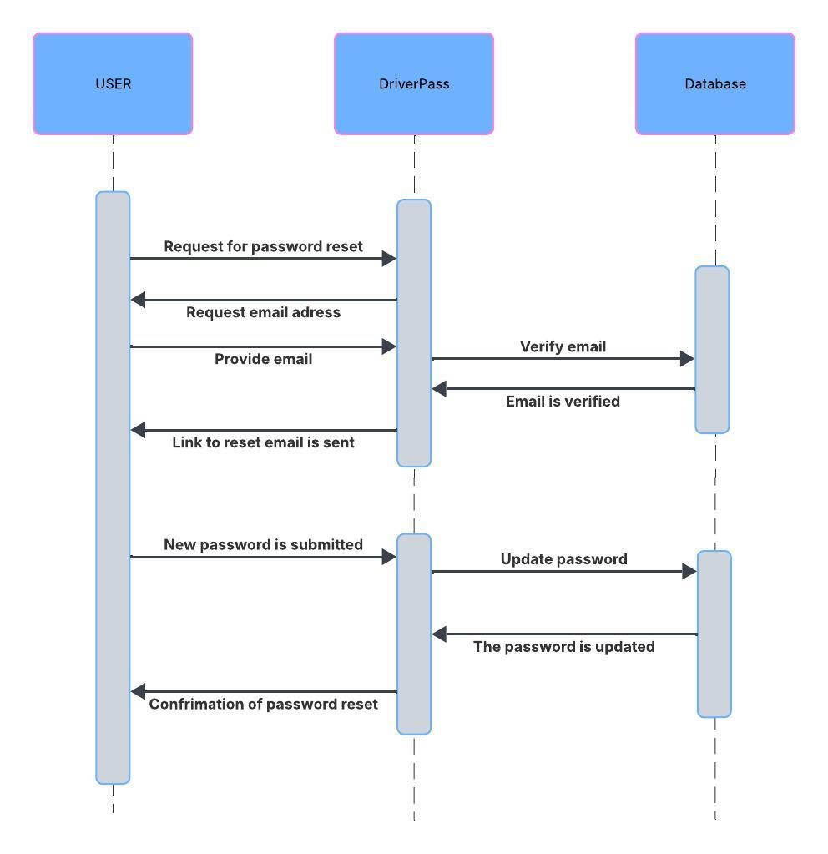

## Technical Requirements

Hardware:

* DriverPass will have to utilize Dedicated servers to ensure the system is working at maximum efficiency.
* Memory/Storage for servers should exceed over expected capacity to prevent and minimize system downtime.
* FIrewalls in place to ensure security

Software:

* Utilize Window servers (more common and easier to manage)
* Security in place to prevent potential malicious attacks or leakage of personal information
* Ability to be accessed by either mobile or web browsers

Infrastructure:

* Activity logs that are accessible to IT Admins, this will allow the appropriate individuals to have a real time and up to date activities to monitor and view security systems.